**COT 4930 COT 5930 EEL 4930 EEL 5661 Robotic Applications (Fall 2022)**

**Homework 1**

# Problem 1: 2D Displacements

A mobile robotic platform can move only straight ahead or straight backwards, along its local XR axis, and it can perform only incremental rotations of θ = π/2 or θ = -π/2 [radians] about a vertical center axis that passes through the local point O.

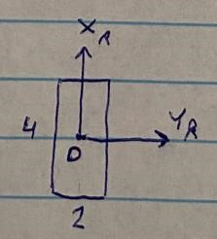

The robotic vehicle cannot translate along its local YR axis.

The robot is standing initially near the south entrance of a maze, at a distance of 20’ (along XR), facing the entrance along the north direction. The robot needs to traverse the maze and come out via the west outlet. The maze and world coordinate frame are shown below:

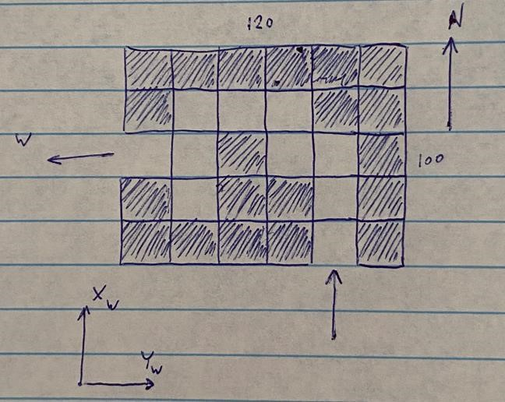

The maze is a 6 by 5 grid of squares of size 20’. Dark color means a wall and light color means an available space. Note that the robot’s dimensions are much smaller than each grid square length, so maneuvering inside the maze is not difficult.

**1.1** Place the world coordinate frame at some arbitrary location (say, the SW corner of the maze, or along the south wall 40’ east of the SW corner, or any other choice that you decide to make). What is the 2D homogeneous transformation of the robot, at its initial position, with respect to the world frame? What is the 2D homogeneous transformation of the robot with respect to the world frame, just as it comes out of the west outlet? These homogeneous transformations are 3x3 matrices.

**1.2** Because the robot’s motions are clearly defined with respect to its own local coordinate frame, it makes sense to model a sequence of robot motions (inside the maze) by post-multiplication of 2D homogeneous transformations. Assume that a human operator drives the robot by a remote-control device, and that the human operator sees the whole maze including the robot inside. Decide what should be the sequence steps of traversing the maze (translation by …, followed by rotation of …., followed again by translation, etc.), find each step’s 2D 3x3 homogeneous transformation matrices, and let MATLAB perform the multiplication of the matrices.

**1.3** Now assume that the robot moves autonomously. It has a sensor that can detect if there is an obstacle ahead. The robot obviously needs to move straight ahead, as far as it can. Decide how the robot should interpret the readings coming from the obstacle-avoidance sensor (Turn left? Turn right? Take a reverse motion and then turn?). Again, write down the sequence of motions and their homogeneous transformations. Many will be identical to what you wrote in (1.2), but here and there you will have to deviate. Again, let MATLAB perform the multiplications.

**1.4** Your maze-traversing method, that you developed in (1.3), should work for most, if not all, other mazes. Create a new maze (maybe slightly larger than the previous one and show that your algorithm works.

**1.5 Bonus 0.5% coding activity:** Write the MATLAB code that plots your 1.4 robot motion overlayed on top of the maze’s map. MATLAB has a “map” command. RTB has a “makemap” command.

# Problem 2: 3D Displacements

In the picture below you see a rectangular box of dimensions 1’x2’x3’ in two poses with respect to the world coordinate frame {W}.

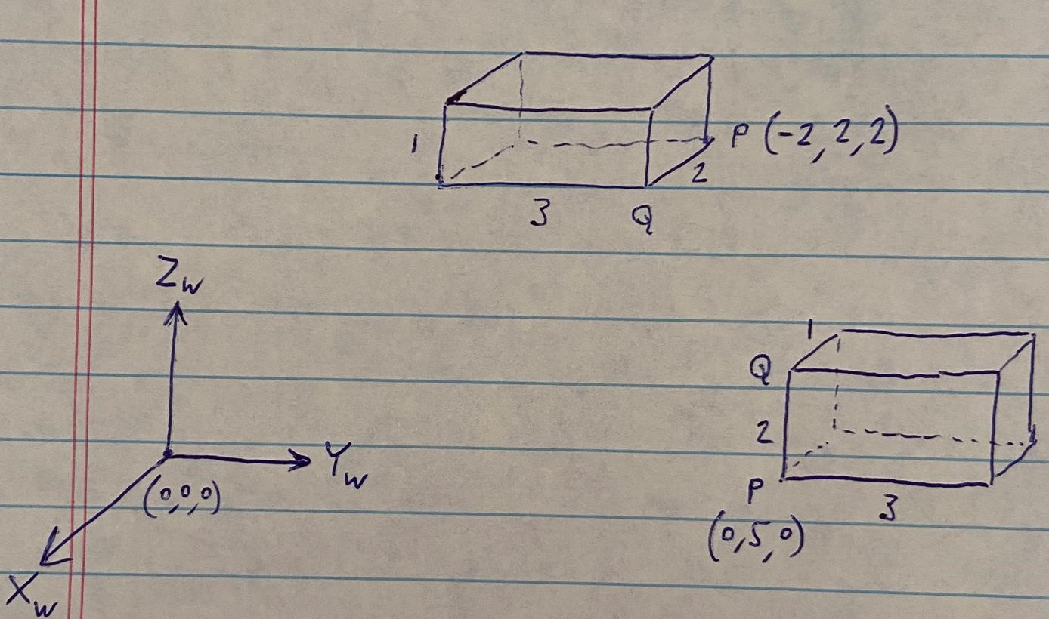

At the initial position of the box, the XYZ coordinates of point P are (0,5,0). At the final position of the box, point Q is at (-2,2,2) with respect to the world frame. Note a second point Q, at each of the positions. **Error Correction: In the final position, point Q is at (-2,2,2), not point P.**

**2.1** What is the 4x4 homogeneous transformation of the first pose of the box with respect to the world frame? What is the transformation of the second position with respect to the world frame? What is the transformation from the first pose of the box to its second pose?

**2.2** Describe the sequence of “simple displacements” that take the box from its initial pose to its final pose. By “simple displacement step” we mean “translation, or a rotation by 900 or -900”.

Assume that each step is done with respect to the box’s local coordinate frame arrived at the end of each previous step. Are you creating a sequence of post-multiplied transformations, or premultiplied transformations? (Answer: Post multiplications).

**2.3** How would you move the box from its initial pose to its final pose by means of premultiplications of simple displacements’ homogeneous transformations? Show a sketch of the box position and orientation at the end of each step. Do the sketching either manually or with the aid of MATLAB.

**2.4** Use MATLAB to find the ZYZ Euler angles of the box homogeneous transformations (of 2.1) in its initial and final poses.

**2.5** Use MATLAB to find the screw axis vector (with respect to {W}) and the single screw rotation that takes the box from its initial position to its final position.

# Problem 3: Task Description

The task involves the welding of two 2”x4” planar rectangular pieces of metal (like the one shown below) to create a L-shaped bracket (also shown below):

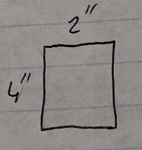 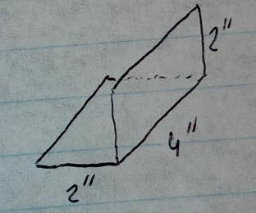

The thickness of each piece of metal is d = 2mm. There are hundreds of such pieces stacked inside a gravity feeder. One cycle of the task involves the making of one bracket.

**3.1** Break one task cycle into a sequence of steps that a human operator must take to get the job done. Describe each step verbally (and very briefly).

**3.2** Need to replace the manual labor by automation. Revisit the steps of (3.1) and try to find a sequence of steps, that can be automated, to perform the job, starting from a part falling from the feeder into a conveyor belt, and ending with the outgoing bracket product placed on the same (or maybe another?) conveyor belt.

**3.3** What is the minimum number of robot manipulators that you think may be needed to perform the steps outlined in (3.2)? Try to get by with as few robots as possible. For each robot mention the geometry that the robot must have, and its end-effector’s tool. Does each robot work at a different station of the automation line? Are there stations in which more than one robot may be needed? Briefly answer each question.

**3.4** In addition to the robot (or robots) mentioned in (3.3), are there any other special-purpose devices or rigs that are needed? Can each robot be programmed “by-doing”?

**Deadline for submission via Canvas Assignments: 9/23/2022 by 11:59 PM.**